Mentors/Practice Educators: Steps to Log into the Brookes electronic Practice Assessment Document
Step 1 Find the site using https://bepad.org.uk
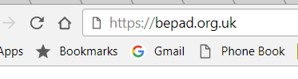
Step 2 ‘Click’ on Mentor/Practice Educator Registration
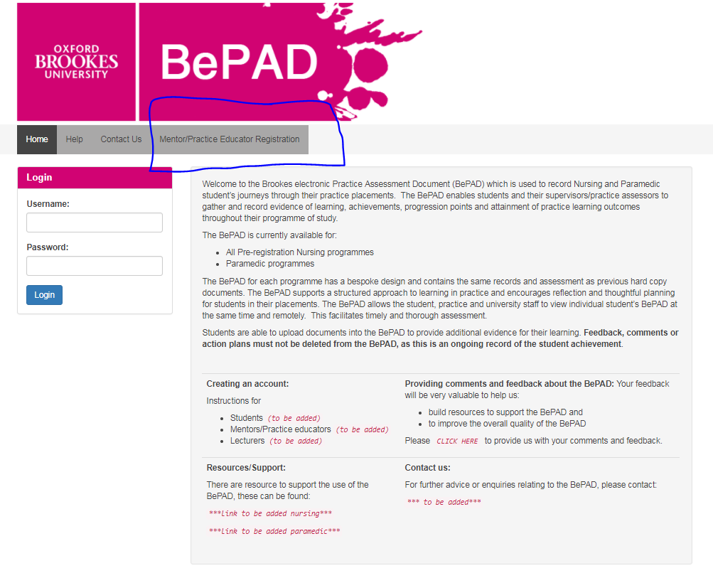
Step 3 Create a Mentor/Practice Educator account. It is IMPORTANT that you use your WORK email account ONLY. And use your full name as your ‘User name’ with a password you will remember.

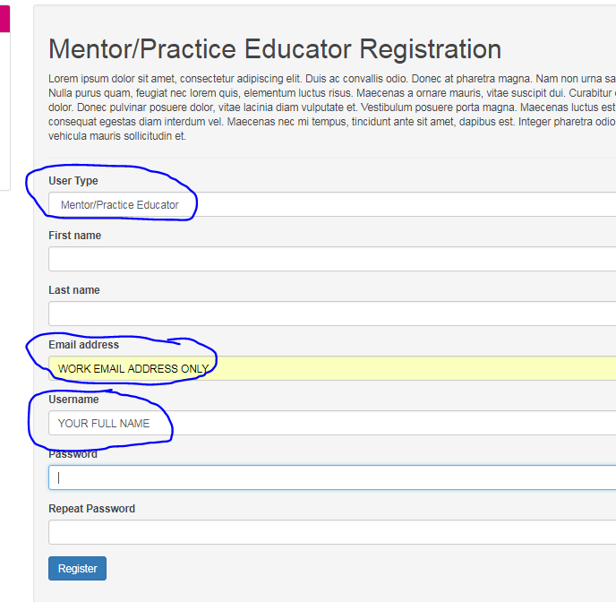

Step 4 ‘click’ register
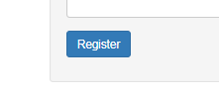
Step 5 You will be accepted by the system so now you can login


